ETL Use case -GCP

This documentation provides a comprehensive overview of the Crowdfunding ETL Pipeline, designed using a Medallion Architecture on Google Cloud Platform. It transforms raw crowdfunding data into an analytics-ready "Gold" layer.

1. Pipeline Architecture
The pipeline follows a modern cloud-native design, utilizing a "Trigger-Action" pattern.
- Ingestion (Landing): CSV files are uploaded to a Google Cloud Storage (GCS) bucket.
- Compute (Cleaning): A Cloud Function (Gen 2) is triggered by GCS events. It uses Python (Pandas) to clean junk rows, parse JSON, and standardize headers.
- Storage (Warehousing): Data is moved through four stages in BigQuery:
  - Landing: Raw, untouched data.
  - Bronze: Validated data with individual tables cleaned.
  - Silver: Unified data; campaign, category, and subcategory tables are joined.
  - Gold: Production-ready views for business metrics.

2. Design Decisions

Why Cloud Functions (Gen 2)?
- Scalability: Automatically scales based on the number of file uploads.
- Cost-Effectiveness: You only pay for the seconds the code actually runs during a file upload.
- Enhanced Resources: Gen 2 allows for up to 32GiB of RAM, which was necessary to handle the memory-intensive imports of pandas and numpy.

Medallion Data Design
- Landing vs. Bronze: We chose to keep a "Landing" dataset to preserve the raw integrity of the data. If the logic fails, we can re-run the pipeline without re-uploading files.
- Silver Merging: We use SQL JOIN operations in the Silver layer to reduce data redundancy,we have used COALESCE to clean columns.
- Gold layer :We have exposed gold layer as views to only display needed information to the business teams.
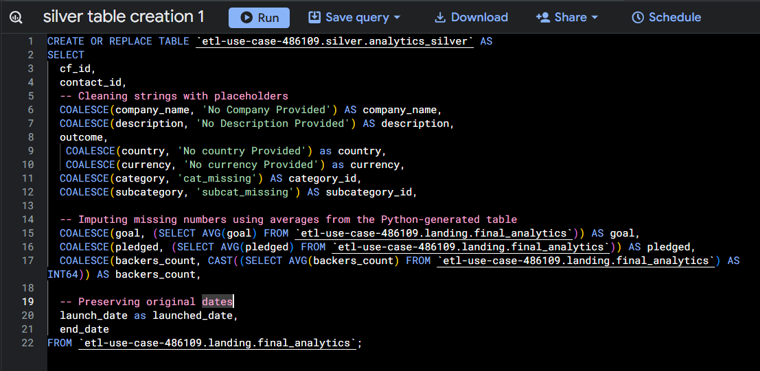
Architecture
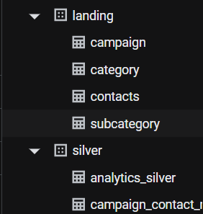
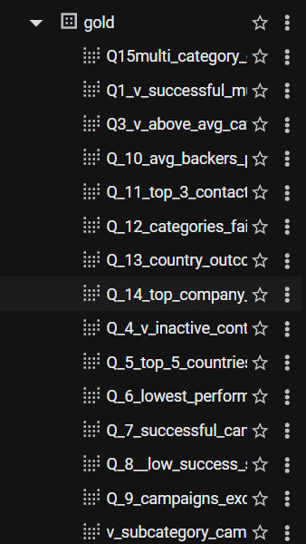

Performance Optimizations
- Internal Initialization: Database clients (bigquery.Client) are initialized inside the function entry point. This avoids "Cold Start" timeouts and ensures the container passes Google’s port 8080 health check.
.

3. Implementation Details

Data Cleaning Logic (Python)
The pipeline handles two distinct data structures within a single function:
- Contacts: Skips the first 3 lines of non-data notes and uses a json.loads loop to extract nested contact information.
- Campaigns: Converts Unix timestamps (integers) to standard SQL DATE format using:
$$\text{date} = \text{pd.to\_datetime}(\text{unix\_val}, \text{unit='s'})$$

BigQuery Layer Logic (SQL)
To ensure the Gold layer is dashboard-ready, we implemented Null-Coalescing and Averaging:
- String Nulls: COALESCE(company_name, 'No Company Provided')
- Metric Imputation: Missing goal or pledge amounts are replaced with the global average of the dataset to prevent skewed analytics.

4. Maintenance & Error Handling
- Logs: All execution details are sent to Cloud Logging. Deployment failures (like the Port 8080 error) are monitored via the Cloud Run revision history.
- Schema Evolution: The pipeline uses df.columns normalization to ensure that minor changes in CSV headers (e.g., "Currency" vs "currency") do not break the BigQuery load.
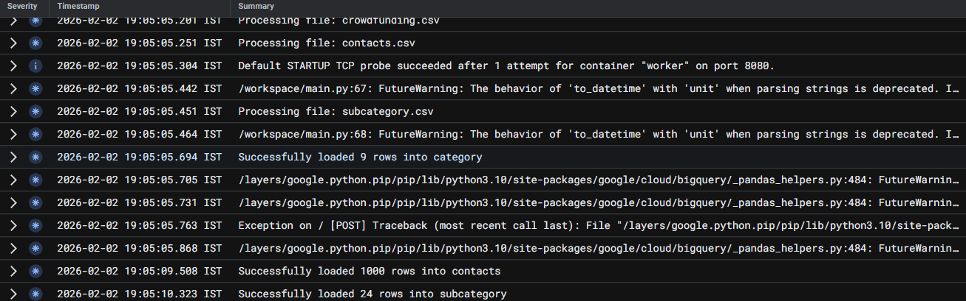

5. Data Cleaning & Transformation Summary
The pipeline performs three levels of transformation: Structural Normalization, Content Cleaning, and Enrichment.

A. Structural Normalization
Before the data touches BigQuery, the Python script ensures the physical structure is consistent regardless of the source file's formatting.
- Case Normalization: All headers are converted to lowercase.
- Symbol Replacement: Spaces and hyphens in column names are replaced with underscores (e.g., Category & Sub-Category becomes category_&_sub_category).
- Whitespace Stripping: All string values and headers are stripped of leading/trailing whitespace to prevent "invisible" duplicates.

B. Specialized Transformation Logic
The script detects the file type and applies specific logic to handle data quirks:

1. The Contacts Parser
The contacts.csv contained non-standard formatting that would crash a normal loader.
- Header Offset: The script ignores the first 3 rows of the file, which contained metadata/notes rather than data.
- JSON Extraction: The core data was stored as a stringified JSON object in a single column. The script uses a try-except block with json.loads() to unpack these into distinct contact_id, name, and email columns.
- String Splitting: The name column is split at the first space to create first_name and last_name fields.

2. The Campaign Date Engine
Raw crowdfunding data uses Unix Timestamps (seconds since Jan 1, 1970). These are unreadable for humans and most BI tools.
- Conversion: We applied the formula:
$$\text{Date} = \text{pd.to\_datetime}(\text{Timestamp}, \text{unit='s'}).\text{dt.date}$$
- Impact: This transformed integers like 1608292800 into readable SQL DATE objects like 2020-12-18.

C. Category & Subcategory Mapping
To support hierarchical reporting, the pipeline breaks down combined strings:
- The Split: The logic looks for the / delimiter in the category column.
- The Result: A value like food/food trucks is split into two distinct columns: category ("food") and subcategory ("food trucks").

D. The "Silver" Layer Imputation (Data Quality)
In the silver stage, we perform "Data Imputation" to ensure dashboards never show broken or empty components:
- Categorical Fill: Replaces NULL values in string columns with standardized placeholders (e.g., "No Company Provided").
- Numerical Imputation: Uses Statistical Mean Imputation.
  - Logic: If a goal or pledged amount is missing, the SQL calculates the average of all other campaigns and inserts that value.
  - Reasoning: This prevents $0$ or NULL values from dragging down the accuracy of global financial aggregates.

